SAFE X SOLUTION
INTERNSHIP WEEK 04
CYBER SECURITY BLUE TEAM G4
SUBMITTED BY : MARYAM REHAN
SECURITY MISCONFIGURATION (HTTP HEADERS) DETECTION TOOL

Introduction:
Security misconfiguration is a common web application security issue that occurs when security settings are missing, incorrectly configured, or not properly enforced. HTTP security headers provide an additional layer of protection by instructing web browsers to apply specific security controls when handling web application content.
This project focuses on the design and implementation of a lightweight defensive detection tool for identifying missing HTTP security headers. The tool was developed in Python and tested against an authorized local laboratory web application environment.
The scanner checks selected HTTP security headers, identifies whether each header is present or missing, displays detected header values as evidence, and provides basic remediation guidance. It also demonstrates automated testing of multiple authorized URLs.

Objective:
The primary objective of this project is to design and implement a reusable security-header detection tool that can automatically analyze HTTP responses and identify potential security misconfigurations.
The specific objectives are to:
- Detect missing HTTP security headers.
- Identify security headers that are already present.
- Display header values as evidence.
- Handle HSTS appropriately when testing HTTP targets.
- Support testing of multiple authorized URLs.
- Produce clear and understandable security findings.
- Provide basic remediation recommendations.
- Demonstrate the limitations of automated security-header detection.

Scope:
The scope of this project is limited to the detection and analysis of HTTP security response headers.
The tool checks the following six security headers:
Content-Security-Policy (CSP)
Strict-Transport-Security (HSTS)
X-Content-Type-Options
X-Frame-Options
Referrer-Policy
Permissions-Policy
The project does not perform exploitation, penetration testing, vulnerability exploitation, or comprehensive web application security testing. All testing was conducted against authorized local laboratory targets.

Security Headers Overview:

Content-Security-Policy:
Content-Security-Policy (CSP) is a security mechanism that allows a web application to control the sources from which browsers can load content. A properly configured CSP can provide an additional layer of protection against cross-site scripting and other content-injection attacks.

Strict-Transport Security:
Strict-Transport-Security, commonly known as HTTP Strict Transport Security (HSTS), instructs browsers to access a website using HTTPS. It helps protect HTTPS-enabled applications against certain downgrade and man-in-the-middle scenarios. Since the laboratory targets used in this project were accessed through HTTP, HSTS was not evaluated as a normal missing-header finding.

X-Content-Type-Options:
X-Content-Type-Options helps prevent MIME-type sniffing by instructing the browser to respect the declared Content-Type of a resource. The commonly recommended value is X-Content-Type-Options: nosniff.

X-Frame-Options:
X-Frame-Options controls whether a web page can be displayed inside frames such as an iframe. A suitable configuration can help reduce the risk of clickjacking attacks. The tested application returned X-Frame-Options: SAMEORIGIN.

Referrer-Policy:
Referrer-Policy controls the amount of referrer information that a browser sends when navigating from one resource to another. A suitable policy can reduce unnecessary disclosure of URL information.

Permissions-Policy:
Permissions-Policy allows a website to control access to certain browser features, such as camera, microphone, and geolocation. It can be used to restrict browser capabilities that are not required by the application.
Tool Design and Implementation:
The security-header detection tool was implemented in Python using the requests library.
Target URL
↓
Send HTTP GET Request
↓
Receive HTTP Response

↓
Read Response Headers
↓
Check Required Security Headers
↓
Classify Header Status
↓
Display Findings and Evidence
For each target URL the scanner performs the following steps:
- Sends an HTTP GET request to the specified URL.
- Records the HTTP response status code.
- Retrieves the response headers.
- Compares the received headers against the predefined security-header list.
- Reports a header as PRESENT when it is found.
- Reports a header as MISSING when it is not found.
- Reports HSTS as NOT EVALUATED when the target is accessed through HTTP.
- Displays the results in a readable format.

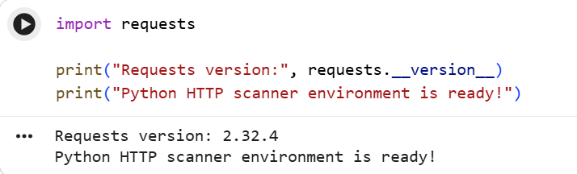
Figure 1: Python HTTP Scanner Environment Scanner Implementation

Detection Logic:
The detection logic is based on checking the presence of predefined HTTP response headers.

Present Header:
When a required security header is found in the HTTP response, the scanner reports it as:
[PRESENT] Header-Name: Header-Value
The actual value returned by the target is displayed to provide evidence of the detected configuration.

Missing Header:
When a required security header is not included in the HTTP response, the scanner reports:
[MISSING] Header-Name
This indicates that the particular header was not detected in the tested response.

HSTS Handling:
HSTS is treated differently from the other headers. Since the laboratory targets were accessed using HTTP rather than HTTPS, the scanner does not classify HSTS as an ordinary missing-header finding.
[NOT EVALUATED] HSTS - Target uses HTTP
This prevents the tool from incorrectly interpreting an HTTP test as an HTTPS HSTS configuration test.
Multiple URL Testing:
To demonstrate that the tool can be reused for more than one target, multiple authorized laboratory URLs were stored in a urls.txt file.
The following URLs were tested:
http://localhost:3000
http://127.0.0.1:3000
The scanner automatically processed each URL and displayed its corresponding HTTP status and security-header results.
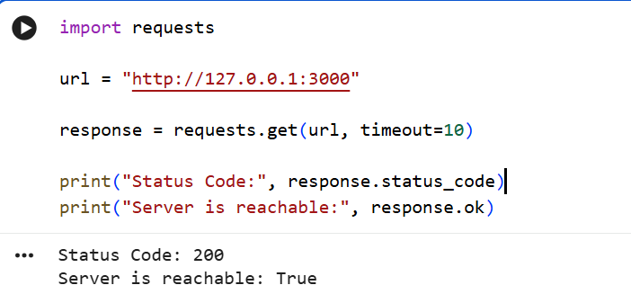
Figure 2: URLs Configuration (urls.txt)
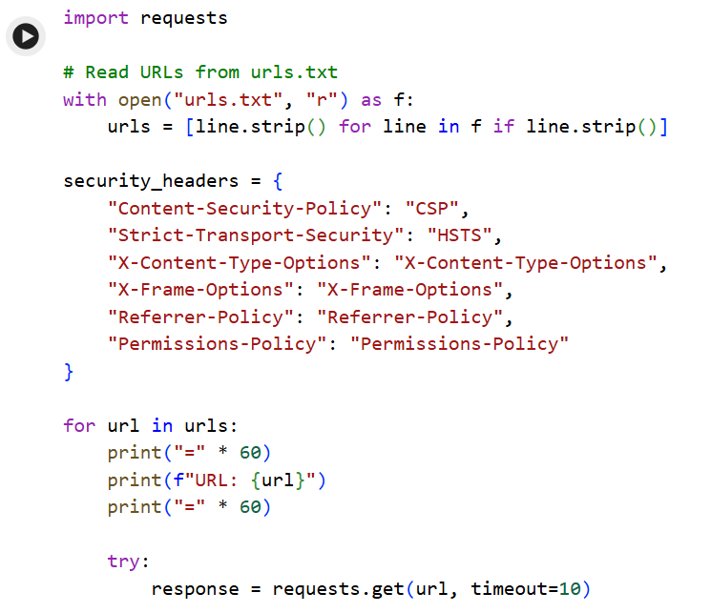

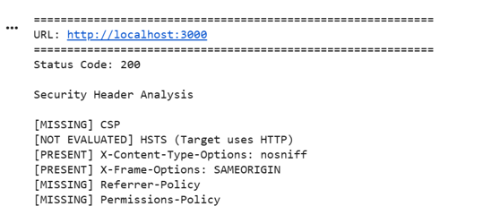
Figure 3: Multiple URL Security Header Testing
Testing Results:
The security-header detection tool was tested against two authorized local laboratory URLs. Both targets returned an HTTP response with status code 200. The results were consistent across both URLs.
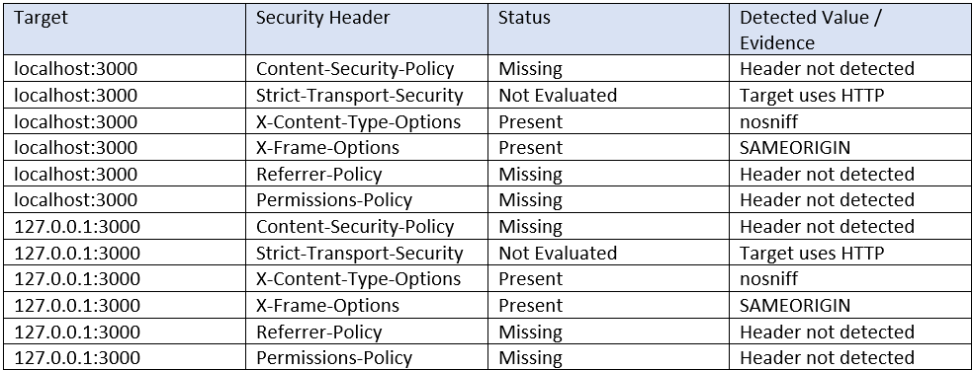
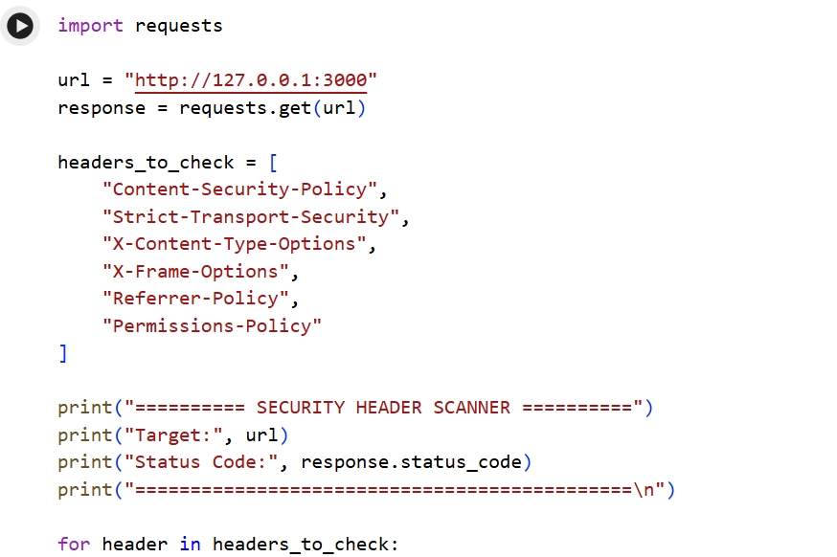
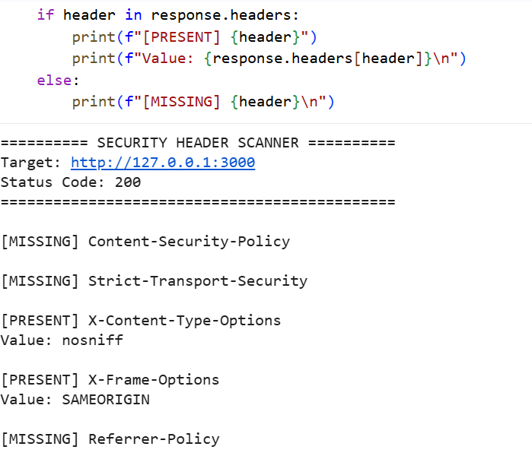

Figure 4: Final Security Header Detection Results
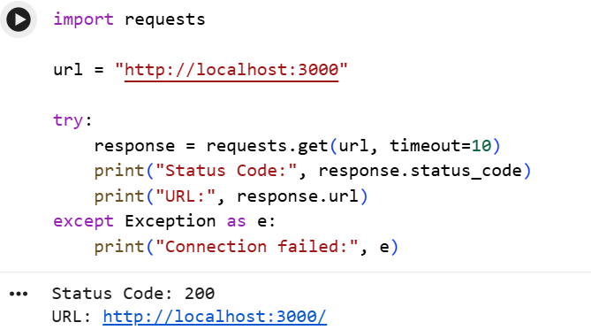
Figure 5: Single URL Testing
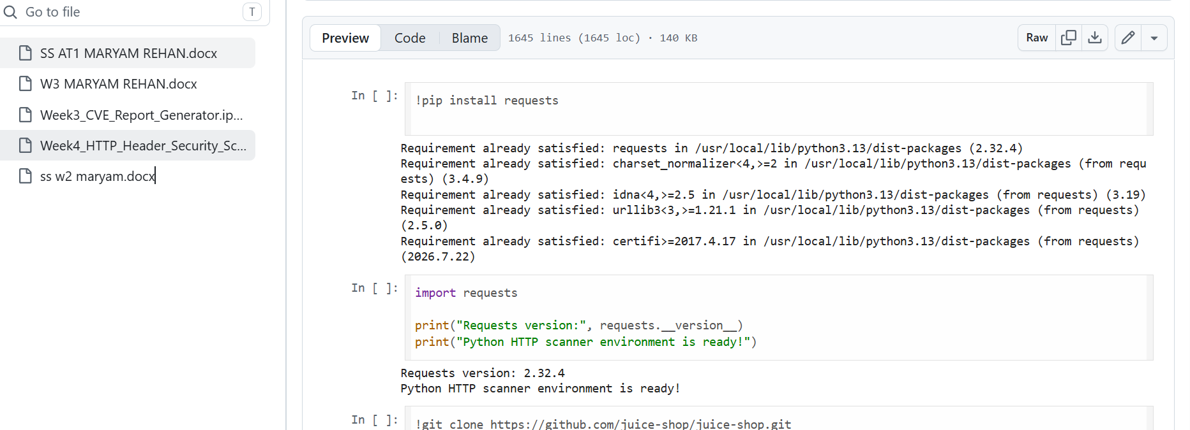
Figure 6: GitHub Repository
Findings and Remediation:
- Content-Security-Policy Missing:
Status: Missing
CSP was not present in the tested responses. It can provide an additional layer of protection against content-injection risks.
Remediation: Configure an appropriate CSP based on application requirements.
- Referrer-Policy Missing:
Status: Missing
Referrer-Policy was not present.
Remediation: Configure a suitable policy, such as strict-origin-when-cross-origin.
- Permissions-Policy Missing:
Status: Missing
Permissions-Policy was not present.
Remediation: Restrict unnecessary browser features according to application needs.
- HSTS Not Evaluated:
Status: Not Evaluated
The targets used HTTP, so HSTS was not evaluated.
Remediation: Enable HSTS when the application is served over HTTPS.
- X-Content-Type-Options:
Status: Present
The response contained nosniff.
Remediation: The recommended nosniff value was present.
- X-Frame-Options:
Status: Present
The response contained SAMEORIGIN.
Remediation: This provides protection against certain clickjacking scenarios.
Open-Source Scanner Comparison:
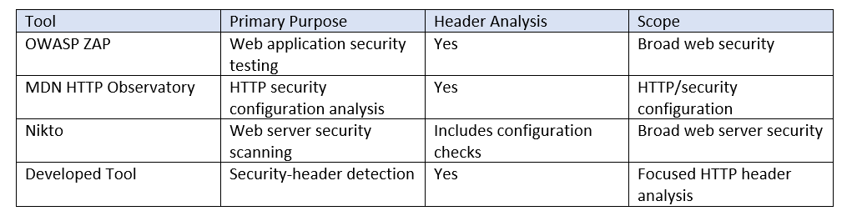
Limitations:
- Checks only predefined security headers.
- Does not perform comprehensive vulnerability scanning.
- Does not exploit security weaknesses.
- Does not determine whether header configurations are optimal.
- Does not perform detailed CSP directive analysis.
- HSTS is not evaluated for HTTP targets.
- Results depend on the HTTP response.
- Does not replace comprehensive security-testing platforms.
- Testing was limited to authorized local laboratory targets.

Conclusion:
This project demonstrated the development of a lightweight Python-based HTTP security-header detection tool. The scanner sends HTTP requests, analyzes response headers, and identifies security-header configurations.
The tool was tested against two authorized local targets, both returning HTTP Status Code 200. CSP, Referrer-Policy, and Permissions-Policy were missing, while X-Content-Type-Options and X-Frame-Options were present. HSTS was not evaluated because the targets used HTTP.
Overall, the project demonstrated how automated HTTP-header analysis can help identify potential security misconfigurations and provide basic remediation guidance.

